**Log into Aurora (LIMS) This provides information on how to log into the system for a designated role through Citrix Receiver.**

|  |  |
| --- | --- |
| Open Citrix | Click either the **Citrix icon from Desktop**.  picture, Picture  Or, from the Start icon, select **All Programs > Citrix folder**  picture, Picture. |
| Open Aurora | Click on **Aurora Folder**.  Click on **Aurora** **Production Icon** to open the system.  NOTE: *If you only have one role, the Main Menu for your role is displayed.*  Picture 1051, Picture |
| Selecting your role – If you have more than one role as defined within the system | Select suitable **Role** to login if you have more than one role.  Your Main Menu screen will be displayed for the role you selected. |

**Log out of Aurora (LIMS)**

This provides information on how to switch to a different role if you have more than one role within the Aurora (or LIMS – Laboratory Information Management System) and how to exit the system.

|  |  |
| --- | --- |
| Switching Roles | Click **Log Out LIMS** Picture 1066, Picture  icon on the Main Menu to log out of current role and log into another role.  Click on **Log into LIMS** Picture 21504, Pictureicon.  Select suitable **Role** to login if you have more than one role. |
| Quit (Exit) LIMS system | Click **Quit LIMS** Picture 21505, Pictureicon in order to log out of the system entirely.  Result: The **Please Confirm** window opens.  Picture 35, Picture  Click on the **Yes** button to exit. |

**Project, Sample, Test & Result Levels**

This provides information on how to view information at the Project, Sample, Test, or Result Level.

|  |  |
| --- | --- |
| Project Level | At the project level, it has general information about the project:   |
| Sample Level | The next level is the sample level:  Picture 63, PicturePicture 3, Picture  It is displayed as a Conical Flask and the color in the Flask, represents the status of the sample.  NOTE: *The color depends on what has been entered at the test level, which then rolls-up to the sample level and if the sample has been received*  At the sample level, it contains:   * Unique sample number – system generated * Sample Type:  SMP – Sample; SUB – Sub-sample; COM – Composite; EXT - External * The description of the sample – maximum of 254 characters |
| Test Level | Group 5, Grouped object  Under the sample level, is the test level.  When a test or an analysis is added to a sample, then it displays the test level under the sample and contains the test name, the report name in brackets, and the number of the replicate. |

|  |  |
| --- | --- |
| Result Level | Group 4, Grouped object    Under the test level is the result level, which contains the components for the test and contains each component where data would need to be added.  In addition, once you enter in a Test % Complete, this will be displayed as a component under the test level; this is because it is an optional field. |
| Example of the different levels | Below is an example of how the different levels are displayed for the sample, test, and result levels:  picture, Picture |

**Icons for Sample, Test, Result**

This provides information on how to read and understand the various icons next to the sample flask, Test beaker and Result test tube

|  |  |
| --- | --- |
|  | Next to each flask, beaker or test tube may have an icon, which indicates different information. |
| Under Investigation - picture, Picture | The magnifying glass icon indicates that the sample, test, or result is still under investigation.  An example is where a sample may not be assigned to a project and using Investigation Manager module to assess what to do with the sample. For datasheet workflow, this feature is not used. |
| Authorized - picture, Picture | The sample, test or result is complete and is authorized to go to the next step.  EXAMPLE: *The sample is complete and all tests have been finished; the Reviewer reviews the results and authorizes the sample to go to the next step.  Or, if using datasheet workflow, then indicates going to the next step.* |
| Modified - picture, Picture | The sample, test or result has been modified.  EXAMPLE*: A test result needs to be changed since an incorrect value was entered. Once the correct value is added and saved, the result test tube will have a yellow triangle next to the test tube. For datasheet workflow, if you update the percent complete from 5 to 25%, then the yellow triangle will be displayed.* |
| Rejected - picture, Picture | The sample, test or result is rejected  EXAMPLE: *The sample has completed testing and the Reviewer reviews the results and rejects the sample since the sample may need to be retested again*.  For datasheet workflow, this feature is not used. |
| Unknown  - picture, Picture | The sample, test or result is unknown. There could be various reasons for this icon.  EXAMPLE: *There could be a test method attached to the sample and that if the lab tech needs to review the test method, then it would open the information associated with the sample.  For datasheet workflow, there is no information associated with this icon.* |
| Cancelled - picture, Picture | The sample, test or result is cancelled  EXAMPLE: *The sample, test or result is no longer required.* |
| Retest -  picture, Picture | The test is identified as a retest.  EXAMLE: *A retest is required and user needs to manually link the original test to the new test or “retest”.* |

Here is an example and the description of each icon:

TextBox 9, TextboxPicture 6, Picture

**Quick Reference for each icon:**

|  |  |
| --- | --- |
| Icon | Description |
| picture, Picture | Sample, test or result is Under Investigation |
| picture, Picture | Sample, test or result is Authorized |
| picture, Picture | Sample, test or result is Modified |
| picture, Picture | Sample, test or result is Rejected |
| picture, Picture | Sample, test or result is Unknown |
| picture, Picture | Sample, test or result is Cancelled |

**Statuses for Sample, Test, Result**

|  |  |
| --- | --- |
| Un-received Sample | An empty flask at the sample level indicates that the samples have been requested and has not been received into the system    (picture, Picture). |
| Incomplete | At the sample level, indicated by the blue partially filled flask, that samples have been received and testing has not started  (picture, Picture).  And, for the test level, indicates an empty beaker since the test has not been started since no results have been captured     (picture, Picture).  And, for the result level, indicates by an empty test tube, that no results have been captured for a test (picture, Picture). |
| In Progress and In Specification | The Green color indicates that testing has begun and the sample, test, or result is within specification to date (picture, Picture,picture, Picture).  This could be a specification set by a client and been applied to that analysis. For example, a client may specify that their density should not be greater than 100 kg/m3 and we measured a value of 98 kg/m3.  For datasheet workflow, we are only using the status of InProgress. |
| In Progress and Out of Control | The yellow color indicates that testing has begun and that the sample, test, or result is out of control. This is where if the limit is set between certain values and anything outside of this range would be out of control. (picture, Picture, picture, Picture).  This is possibly, where a test method indicates that the density should not exceed + 5 kg/m3 from what the client has indicated and we measure a value of -10 kg/m3 and would be considered out of control.   For datasheet workflow, this feature is not used. |
| In Progress and Out of Specification | The red color indicates that testing has begun and that the sample, test, or result is out of specification. This is where if the limit is set between certain values and the result was outside of the specified range; this would be considered out of specification. (picture, Picture, picture, Picture).  This is where for a test the density needs to be between 90 and 100 kg/m3 and we measure a value of 102 kg/m3.    For datasheet workflow, this feature is not used. |
| Complete and In Specification | The Green color indicates that testing is complete and the sample, test or result is within specification (picture, Picture, picture, Picture, picture, Picture).  This could be a specification set by a client and been applied to that analysis. For example, a client may specify that their density should not be greater than 100 kg/m3 and we measured a value of 98 kg/m3.   For datasheet workflow, we are only using the status of Complete.  Picture 1036, PictureAlso, a sample may be partially filled and have a status of Complete if the test is cancelled:  picture, Picture |
| Complete and Out of Control | The yellow color indicates that testing is complete that the sample, test, or result is out of control. This is where if the limit is set between certain values and anything outside of this range would be out of control. (picture, Picture, picture, Picture, picture, Picture)  This is possibly, where a test method indicates that the density should not exceed + 5 kg/m3 from what the client has indicated and we measure a value of -10 kg/m3.    For datasheet workflow, this feature is not used. |
| Complete and Out of Specification | The red color indicates that testing is complete and that the sample, test, or result is out of specification. This is where if the limit is set between certain values and the result was outside of the specified range; this would be considered out of specification. (picture, Picture, picture, Picture, picture, Picture).  This is where for a test the density needs to be between 90 and 100 kg/m3 and we measure a value of 102 kg/m3.   For datasheet workflow, this feature is not used. |
| Review each color designation | Below are examples for the sample, test, and result level and possibly, what colors and how much is filled in their containers for each. |

**Quick Reference of the sample, test and result statuses:**

Text Box 56, TextboxText Box 57, TextboxText Box 58, Textbox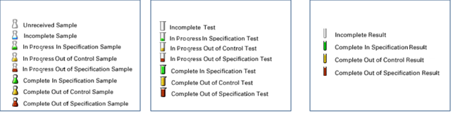

**Main Menu Icons**

This provides information on the icons on the Tester Main Menu. 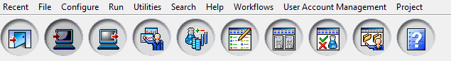

|  |  |
| --- | --- |
| **Icon** | **Description** |
| Quit LIMS   picture, Picture | After selecting this icon, the system will prompt you if you are sure that you want to quit (or exit) the application.  If you confirm yes, then the application will close. |
| Log into LIMS   picture, Picture | When active, the system will ask which role you would like to log into. Use this feature when you have more than one role within the LIMS system.  Once you select a role, the Main Menu will be displayed for that role. |
| Log out of LIMS  picture, Picture | Logs out of your current role; you will then need to log into LIMS if you want to change your role. |
| Open the Project Manager  picture, Picture | After selecting this icon, the Project Manager window opens.  This is where a project can be searched in order to select and open a project that you want to view information or to be able to edit the project. |
| Test Editor   picture, Picture | After selecting this icon, the Sample Prompter is displayed.  After selecting a sample, the Test Editor window opens, so that test, analysis or a test list can be added to a sample. |
| Test Results     picture, Picture | After selecting this icon, the Sample Prompter is displayed.  After selecting a sample, the Result Entry window opens to enter in test results. |
| Run Reports picture, Picture | After selecting this icon, the Select Report Dialog window opens.  This is where you are able to select and run a report that has been developed. |
| Review Samples picture, Picture | After selecting this icon, the Sample Prompter is displayed.  After selecting a sample, the Review Dialog window opens to review the samples. |
| Open the Project Folder picture, Picture | After selecting this icon, the Folder Manager window opens.  This is where samples are displayed in a folder – you can create a new folder from a template or you can select a folder that has been previously defined. |
| On-Line Help picture, Picture | After selecting format, opens to the LabWare v6 Technical Manual |

**Project Overview**

This provides information on the Main tabs.

|  |  |
| --- | --- |
| Open an Aurora Project | View the Main tabs:   * Picture 1050, PictureSummary * Samples * Results * Items |
| Summary Tab | Picture 1058, PictureOn the left panel, is the Summary, Project Result Info and Sample info. |
| Samples Tab | The Samples view displays all the samples belonging to a project.  Contains information about the status of the sample(s), any test(s) associated with the sample or any test results.  Picture 1059, PictureThe Count field (upper right hand corner) displays the number of samples in the project.      Picture 1064, PictureThe Samples view consists of two sections:  1) the sample list and 2) the details of the sample, test, result:         1. The left pane displays all the samples in the project in a tree view and can be expanded to view the test or result level 2. The right pane displays information in a standard list view. The information displayed will vary depending on which sample, test, or result is selected. |
| Results Tab | Used to view the results that are directly attached to a project. For datasheet workflow, this feature is not used.  NOTE: *These are not the results on the sample/test.* |
| Items Tab | Contains information on the attachments associated with this project  Picture 1067, PictureThe Items tab shows the items on the project.        For datasheet workflow, the instruments and Standards & Reagents are captured under the Meter Use tab in the Items tab.  The user can add or insert new rows into the grid, or delete rows using the Item menu. |

**Under the Summary Tab:**

**Summary Info:**

|  |  |
| --- | --- |
| Created By | This field indicates the User who created the project. |
| Updated On | This field indicates the date of last activity for the project. |
| Owner | This field indicates the Owner of the project and can be defined when the project is created or defaulted in the project template. |
| Closed | The Closed flag indicates the state of the project; either Yes if closed or No if still opened. Note: A Closed project can be Restored. |
| Status | The status of the project is derived from the status of the samples belonging to the project. The initial status of the project, when it is first created and has no samples, is Un-received. When samples are added to a project, the status of the project changes depending on the status of all samples.  A project is Unreceived (U) if at least one sample is unreceived and the remaining samples are either unreceived or canceled.  A project is Incomplete (I) if at least one sample is incomplete and the remaining samples are either unreceived, incomplete or canceled.  A project is Inprogress (P) if at least one sample is InProgress and the remaining samples are unreceived, incomplete, cancelled, complete or reviewed.  A project is Complete (C) if at least one sample is complete and the remaining samples are complete, reviewed (authorized or rejected) or canceled.  A project is Reviewed (V) if at least one sample is reviewed (either authorized or rejected) and the remaining samples are either reviewed or canceled.  A project is Canceled (X) if all its samples are canceled. |

**Project Result Info**

|  |  |
| --- | --- |
| Incomplete  In Progress  Complete  Reviewed  Canceled | Indicates the number of items under the Results tab.  For datasheet workflow, this is not being used. |
| Total | This field indicates the total number of Results items in the Results tab. |

**Sample Info**

|  |  |
| --- | --- |
| Unreceived  Incomplete  In-progress  Complete  Reviewed  Canceled | These fields indicate the number of samples in the project at each of these statuses. |
| Total | This field indicates the total number of samples in the project. |

**Sample Structure**

* Text Box 2, TextboxParent Sample - Each distinct product or construction within a *project* may have its own *sample*.  Below is an example of the parent sample with all the samples associated with the parent sample (Sub-sample, sibling and composite samples):

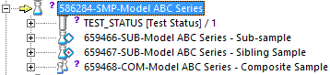

* For datasheet workflow, we are using and defining the parent sample differently than how the data load process would.  For datasheet workflow, the parent sample could be:
* Where all the samples may be in one box
* Or, there are different types of samples that we are requesting from the customer
* Handlers determine the number of samples that enter into Aurora, based on the samples needed and keeping in mind the sample movement of the sample –
* For example, will all samples be in one box and testing in one lab?  If there are multiple labs/teams testing samples in parallel, then there may be multiple samples on a project for ease of sample movement and chain of custody.
* Each *sample* will have a tree structure, similar to folders in Windows. The “root” level may also be called the *master sample*

* Sub-Sample - The *parent sample* may also hold *sub-samples*.
* For datasheet workflow, we use this function when we need to split out a sample from the Parent sample where we may need to transfer the sample to another office

Text Box 2, TextboxPicture 16, Picture

* And, a sub-sample is denoted by the triangle next to the flask and noted as “SUB”
* For data load process, each *sub-sample* will represent a set of specimens from the product in question that all go through the same conditioning

* Sibling Sample – This is where a sample may need to be transferred to another site; a sibling samples is created from a sub-sample and denoted by a red dot in a triangle next to the flask and noted as SUB

Text Box 2, TextboxPicture 14, Picture

* Normally, not used for datasheet workflow

* Composite - Used where individual samples need to be combined (or make a composite).  This is where a lamp shade may be in one box and the lamp base in another box – what you can do is make a composite and this new sample number is the one that is tested.

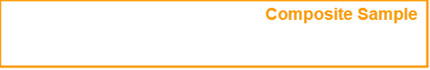

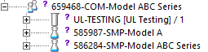

* It will show you which samples created the composite samples; this is where sample #585987 and #586284 made up the composite sample #659468 and denoted by the two smaller flasks and noted as COM
* Normally, not used for datasheet workflow

**Adding Comments for the Project**

This provides information on how to add comments to the project.

*For example:* A situation when to add notes is where the Tester is in-training to add a competency for a test.  In this situation, the Trainer can add comments “Trained XXXXX (who) on XXXXX (and what? Could be one test or all tests)”.  Therefore, add in Internal Notes the following as an example: Trained John Smith on Flammability Test.

|  |  |
| --- | --- |
| Add a comment | Picture 21510, PictureSelect Summary tab and Project sub-tab to add any Project Level or Sample Level comments:                Click on the Internal Notes button.  Result: Running Notes Dialog window opens.  picture, Picture    Enter any comments into the bottom section.  Click on **Insert** button.  Right Arrow 50, ShapePicture 32, Picture    Result: The comment inserted into the top box, Date, Time, and User Stamped.  Or, **OK** button.  Click on the Save icon picture, Picture. |
| Viewing Comment | To view the comment, in the bottom left hand side, double click Note icon picture, Picture.  Result:  Information window opens:  Rectangle 21512, ShapeText Box 47, TextboxPicture 11, Picture  Click on the **OK** button or the **X** to close the Information window. |

**Managing Notifications (Email/Alerts)**

This provides information to receive an alert or notification when an event has occurred.

|  |  |
| --- | --- |
| Open User Account Management | Open the LIMS system, click on User Account Management Menu, and select Update User Account.  Result: LIMS User Configuration Dialog window opens.  Right Arrow 21509, ShapePicture 21508, Picture |
| Assign an event | Click on the double arrows to view the events where you can receive an alert on.  Result: Quick Codes Selection Dialog window opens.  Picture 1025, Picture  Highlight the event that you want to receive an alert on:  LAB_TESTING_COMPLETED – when all the subsample tests have been completed.  Email/notification to Project Owner, Secondary Project Owner.  PROJ_DUE_DATE_CHANGE – when the Lab Due Date is changed, email/notification to Project Owner  PROJ_DUE DATE_PASS – When Lab Due Date is passed, email/notification to Project Owner  PROJECT_COMPLETED – when a project is completed.  Email/notification to Project Owner, Secondary Project Owner.  QUAR_SAMPLE_LOGGED – Whenever a quarantine sample is logged into a site.   Email/notification to any role who create this subscription.  RCV_SAMPLE_TRANSFER – when a transferred sample is received from an external location.    Email/notification to Project Owner, Secondary Project Owner, Lead Tester.  SAMPLES_DIFF_LOCTN – when a sample is received at a different location.   Email/notification to Project Owner, Secondary Project Owner, Lead Tester.  SAMPLE_OUT_QUAR – when a quarantine sample is moved to a project.    Email/notification to any role who create this subscription.  SAMPLE RECEIVED – when a sample is received.   Email/notification to Project Owner, Secondary Project Owner, Lead Tester.  SPECIAL_ATTN – when a sample required special attention, where sample condition not “Good”.   Email/notification to Project Owner, Secondary Project Owner, Lead Tester.  TEST_ASSIGNED_PO – When the Tester is assigned to a sample, email/notification to Project Owner  TEST_ASSIGNED_TESTER – When the Tester is assigned to a sample, email/notification to Tester.  Note only receive if entering in another employee number.  Click on the Assign button.  Result: Highlighted Event will be displayed in lower section.  Click on the OK button to close Quick Code Selection Dialog window.  Click on the OK button LIMS User Configuration Dialog window. |
| Select the Notification type | picture, Picture  Typically for datasheet workflow, select email |
| Acknowledging an Alert | When you receive an alert, enter any comments.  Picture 2, PictureClick on **Acknowledge** button.        Right Arrow 5, Shape  Rounded Rectangle 4, Shape  NOTE:  *If you click on Close, the alert will be visible again*. |

**View Recent Projects**

This provides information on how to check or reference quickly the LATEST 9 records you have worked on.

|  |  |
| --- | --- |
| View Recent Projects on Tester Main Menu or on an Aurora project | Picture 1123, PictureSelect Recent in the Main Menu and then select the project want to open.                **OR**  Select Project Manager to view your recent projects and then select the project.  Picture 1124, Picture |

**Search Function**

This provides information on how to find Projects, Samples, Instruments, Analysis, etc. depending on the role.

|  |  |
| --- | --- |
| Open Search Feature | From Main Menu, click on Search menu.  Picture 1069, Picture |
| Select Item to Search by | After selecting Project Search, the Search Dialog window opens.  *See below for the different search windows*. |
| Enter Data to Search by | Picture 5, PictureAfter entering in data to search by, click on the Search button, any results will be in the table below:              Up Arrow 1086, Shape |

**Project Search**

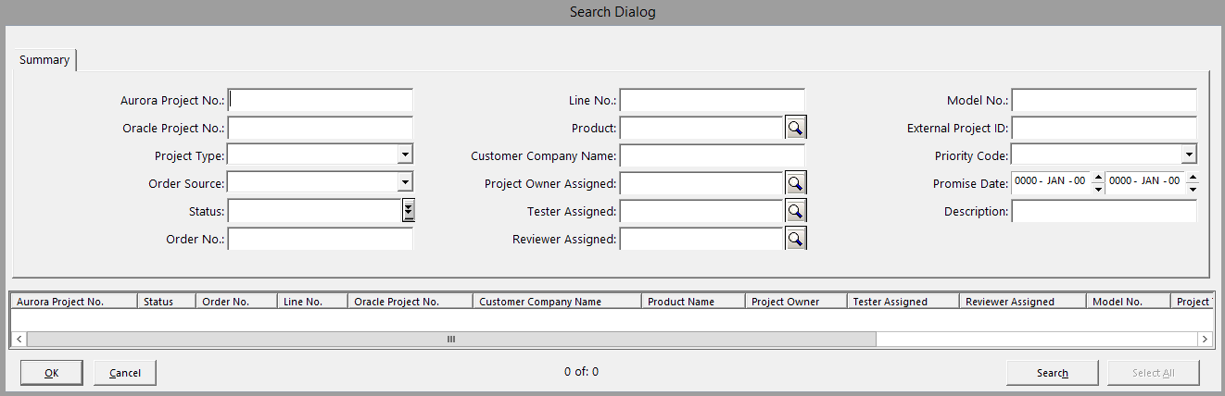

**Sample History Search**

Provides information on the details of the history of the sample

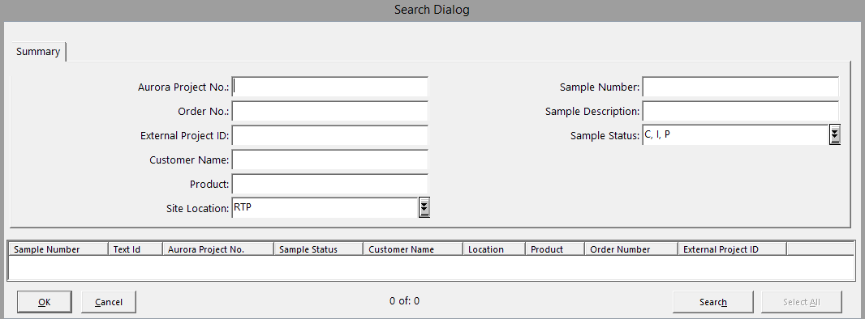

**Sample Search:**

Opens sample folder and able to update some sample fields that normally found in Modify samples window

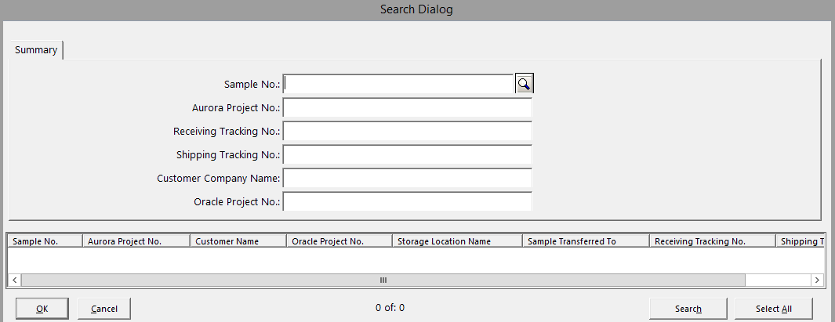

**Sample History Search Folder:**

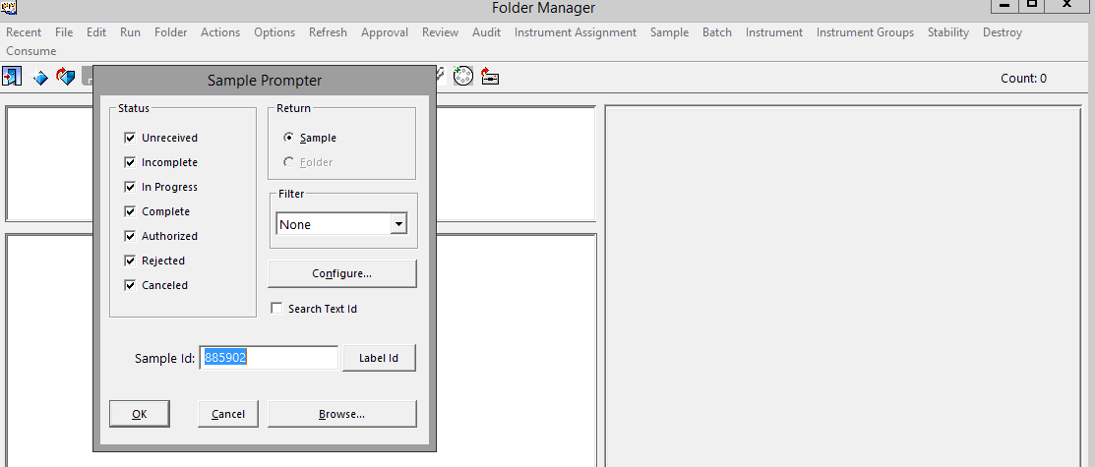

**Rounded Rectangle 6, ShapeViewing Labels**

This provides information on the labels that can be printed.

|  |  |
| --- | --- |
| Sample Label | Picture 30, Picture  Contains the following information:   * Sample Number and the bar code * Sample Description * Customer Name * Received Date * Aurora Project No. * Oracle Order No. * Oracle Project No. * Number of labels associated with the sample |